Project Report

Product Name | Spark on Azure HDInsights
Qualification Name (NICF) | NICF – Diploma in Business Analytics
Module Name (NICF) | NICF Spark on Azure HDInsights

Learner name |  | Assessor name
Goh Rui Kun |  | Ryan Suryanto
Date issued | Completion date |  | Submitted on
1st March 2021 | 9th March 2021 |  | 9th March 2021
Project Title | Credit Risk Analysis

Learner declaration
I certify that the work submitted for this assignment is my own and research sources are fully acknowledged.

Learner signature: RK Date: 9th March 2021

Contents

- Executive Summary
- Initial Data Exploration
- Splitting and Feature Engineering Results
- Training, Testing & Evaluation
- KS Plot
- ROC curve for Logistic Regression
- Lifi Chart
- Operational Metrics Computation & Scores Transformation
- Project Report Sign-off by Mentor & fellow learner

MVP Executive Summary

In this project, we present an analysis based on whether the loan request should be granted or not by the financial institution. There are simulated data containing the borrower’s financial history and information about the loan request, the financial institution can make use of predictive analytics to help them decide whether to grant a loan for each borrower, whereby reducing the number of loans it offers to those borrowers that have higher chance to default which causes losses, thus increase profitability.
In the analysis, we will pre-process the data like cleaning and feature engineering, trains prediction models, and performs scoring via HDInsight Spark cluster with Microsoft R Server. HDInsight is a cloud Spark and Hadoop service for enterprises. HDInsight is also the only managed Hadoop solution with integration to Microsoft R Server. In this analysis, we will use the historical data to predict a model for future loans via the R server in HDInsight. We choose Logistic Regression to train our model which is a standard model used in the Credit Score industry which is different from the more complex models such as random forests or neural networks, it is more understandable through the simple formula generated during the training.
There are 4 steps involved where each step creates a function to perform the task. Step 1 (pre-processing) is to upload the data and perform preprocessing steps which is merging of input data sets and dealing with missing value. Step 2 (feature engineering) is to create the label isBad based on the status of the loan which split the preprocessed dataset into the training and testing dataset and bucketizes all the numeric variables based on the conditional inference trees on the training set. Step 3 (train, score and evaluate) is to train a logistic regression classification model on the training set and save it. During the development, the script will then score the logistic regression on the test set and evaluates the tested model. During the production, the entire input data will be used, and no evaluation is performed. Step 4 (operational metrics) is to computes the expected bad loan rate for various classification decision thresholds and applies a score transformation based on operational metrics.
After the step 4, the development script will runs copy_dev to prod.R to copy the model information from the dev folder to the prod folder for use in production.
First is create the model and score test data where devopment_main.R script is run which include the 4 steps as mentioned above. The input will generate 10,000 rows for training the models, where it will split into train and test dataset. After the script had run, the data files are in the /var/RevoShare/<username>/LoanCreditRisk/dev/temp directory. The models are stored in the /var/RevoShare/<username>/LoanCreditRisk/dev/model directory. The Hive table ScoreData contains the result of the test data. The model will then be copied to /var/RevoShare/<username>/LoanCreditRisk/prod/model directory for production.
Next, we will run the production_main.R script which will run step 1 to 3. It will use the previous trained model and execute the steps to preprocess the data, perform feature engineering and scoring. The input of this script will scored 22 applicants with the model in the prod directory. After the script had run, the Hive table ScoresData_Prod will now contain the scores for the applicants.
After which, we will produce a PowerBI dashboard which can be visualize the scores created form the model. It will then be used to examine the test data to find the appropriate score cutoff which will be used for new loan applicant’s prediction.

Initial Data Exploration

In the project, there are 4 CSV files which are Loan.csv, borrower.csv, loan_prod.csv and borrower_prod.csv. The loan.csv and borrower.csv are the dataset of loan and borrower with 100,000 rows of the simulated data used to build end to end loan credit risk solution. The loan_prod.csv and borrower_prod.csv are datasets of loan and borrower with 22 rows of simulated data used in the production pipeline.
The schema and description of the input tables and variables are shown below:
Loan:
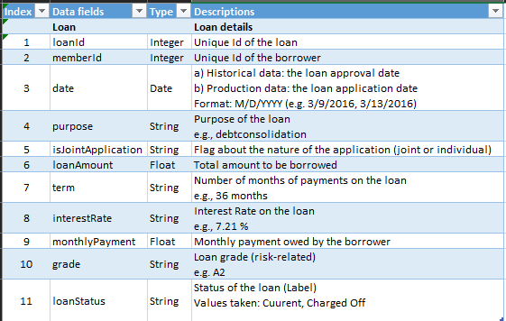

Borrower:
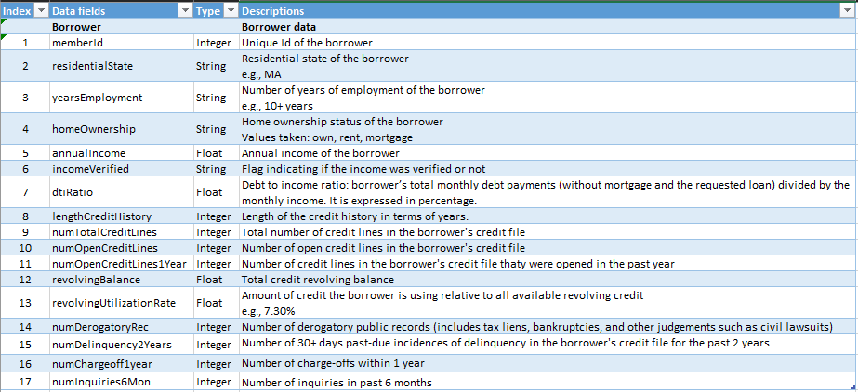

The R codes/script used:
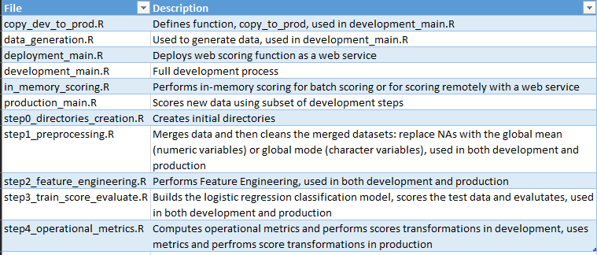

First there will be creating or cleaning of intermediate directories both on edge node and HDFS. These directories will hold all the intermediate processed datasets in the subfolders and will be performed using R Scripts in step0_directories_creation.R file.
Next there will be merging and cleaning the data. For speeding up the computation in this step and the subsequent one, the input data is first converted to .xdf files stored in HDFS, the characters are converted to factors at the same time. The xdf files are then merged with the rxMerge function, which writes the xdf results to the HDFS directory “Merged”. Next the missing values are filled in the merged table, the missing data values of numeric variables are filled with the global mean and the character variables are filled with the global mode. The rxSummary function on the HDFS directory that holds the merged table xdf files provides the names of the variables with missing values, their types, the global means, as well as counts table through which the global modes are computed. The statistics information is saved to be used for production or web scoring stages in the directory LocalModelsDir. If there are no missing values found, the merged data are copied to the folder “Mergedcleaned” on HDFS without missing value treatment.
If there are missing value, it will compute the global means and modes for the variables with missing values by using rxSummary results. The Mean_Mode_Replace function will deal with missing values, which will be called in rxDataStep function which acts on the xdf files of “Merged”.
Next there are the cleaned splits of the merged table “Mergedcleaned” on HDFS which the input is working directories on the edge node and HDFS and the data (loan and borrower csv files), the output which is the statistics summary information saved to the local edge node in the LocalModelsDir folder and the cleaned dataset MergedCleaned on HDFS in xdf format. All above are performed using in step1_preprocessing,R file.

Splitting and Feature Engineering Results

For the feature engineering, new features are designed where categorical versions of all the numeric variables. This is done for the interpretability and the standard practice in the credit score industry. The label isBad specify whether the loan has been charged off or defaulted where isBad = 1 as defaulted and isBad = 0 is in good standing based on loanStatus.
The label isBad is created with the rxDataStep function, the outputs are written to the HDFS directory “MergedLabeled”. The hashcode is created with values corresponding to the hashing loanID to integers which is used for splitting. This hashing function ensures repeatability of the splitting procedure.
The dataset is split into training and testing dataset. This is done by selecting randomly a proportion of the MergedLabeled data. The output will then write to the “Train” directory.
The bins will then be computed that will be used to create the categorical variables with smbinning. As some of the numeric variables have too little unique values, or then binning function did not return significant splits, it is then decided to manually specify default bins in case smbinning does not return the splits. The default bins was determined through an analysis of the data or through running smbinning on a larger dataset. The cutoffs are saved in the directory LocalModelDir that are used for the production or web scoring stages.
The bin computation is optimized by running smbinning in parallel across different cores of the servers, through the use of rxExec function applied in a Local Parallel (localpar) compute context, The rxElemArg argument is used to specify the list of numeric variables need to apply smbinning on.
Next the variables are bucketized based on the computed or specified bins with the function bucketize which wrapped into the rxDataStep function. The output will then written into the HDFS directory MergedFeatures in xdf format.
Next the created variables are converted from character to factors, and the variable information is saved in the directory LocalModelsDir to be used for production or web scoring stages. The data with the correct variable types is written to the directory “MergedFeaturesFactors” on HDFS which the input is the working directories on the edge node and HDFS and the splitting ratio that correspond to the proportion of the input dataset that will go into the training set, the output will be the cutoffs saved to the local edge node in the LocalmodelDir folder, factor information saved to the local edge node in the LocalModelsDir folder and analytical dataset with correct variable types MergedFeaturesFactors on HDFS in xdf format. All above are performed by step2_feature_engineering.R file.

Training, Testing & Evaluation

The xdf files are split in MergedFeaturesFactors into a training and testing dataset. This is done through rxDatastep functions, according to the splitting ratio defined and used in initial data exploration and using the same hashcode created in the initial data exploration.
A logistic regression is trained on training dataset and is saved on the local edge node in the LocalModelsDir folder. It would be used in the production or web scoring stages.
Training a logistic regression for loan credit risk prediction is a standard practice in the credit score industry. Different from the more complex model such as random forests or neural networks, it is understandable through the simple formula generated during the training. The bucketed numeric variables help us to understand the impact of each category and variable on the probability of the default. The variables used and with their respective coefficients are sorted by order of magnitude are stored in the data frame Logistic_Coeff that retuned by the step 3 function.

KS Plot

KS (Kolmogorov-Smirnov) statistic is a standard performance metric in the credit score industry which represents how well the model can differentiate between the good credit applicants and the bad credit applicants in the testing dataset. The KS plot corresponds the two cumulative distributions of the predicted probabilities where is_bad = 1 (bad loans) and good is_bad = 0 (good loan). KS is the biggest distance between those two curves.

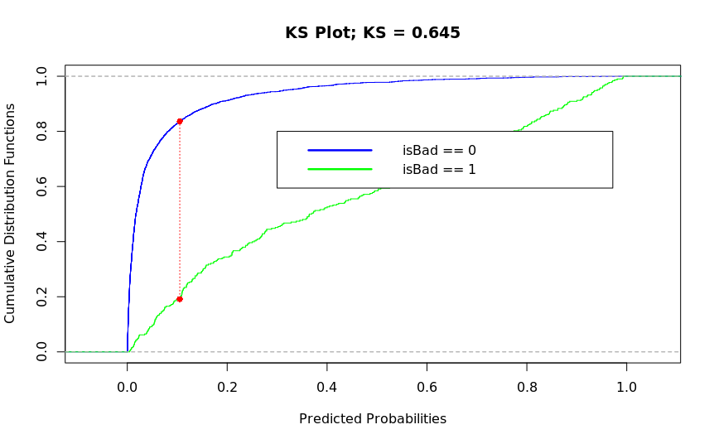

The classification performance metrics are computed on the confusion matrix which are dependent on the threshold chosen to decide whether to classify the predicted probability as good or bad loan. At the point of the x axis in the KS plot where the curves are the farthest possible is used as the threshold.

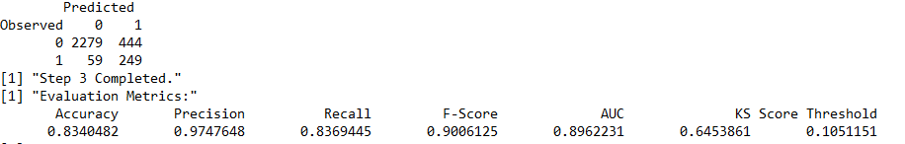

ROC curve for Logistic Regression

The AUC (Area under the curve) for the ROC represents how well the model can differentiate between the good credit applicants from the bad credit applicants given a good decision threshold in the testing dataset. The ROC represents the true positive rate in the function of the false positive rate for various possible cutoff.
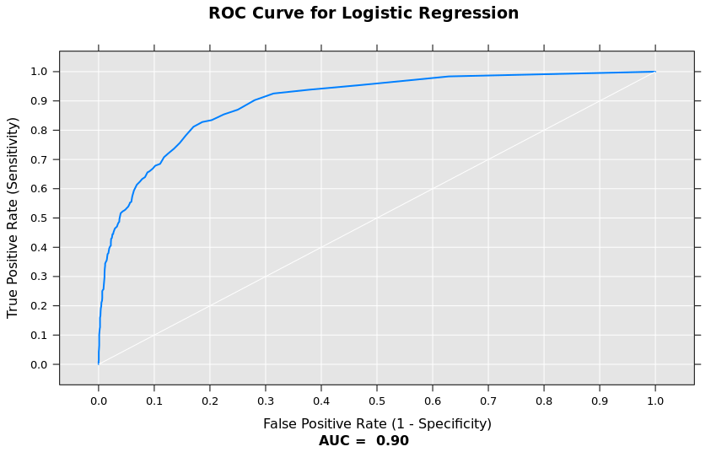

Lift Chart

The Life chart represents how well the model can perform compared to a naïve approach. At the level where the naïve effort could produce a 10% rate of positive predictions, a vertical line on x = 0.10 is drawn and the lift value is read where the vertical line crosses the life curve. If the life value is 3, the model would produce 3 times of the 10%, which is 30% rate of positive predictions.

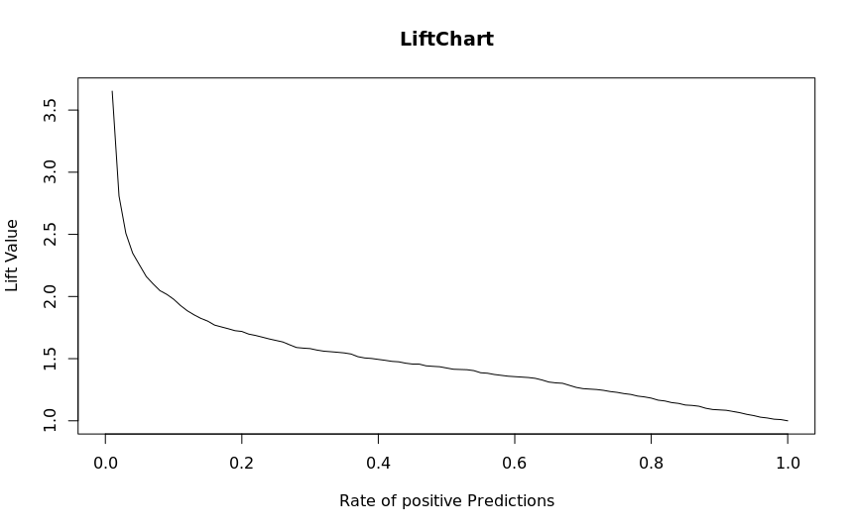

The input will be the working directories on the edge node and HDFS, the splitting ratio corresponding to the proportion of the input dataset that will go to the training dataset. The output will be the logistic regression model saved to the local edge node in the LocalModelsDir folder, the logistic regression formula saved to the local node in the LocalModelsDir folder and the prediction results given by the model on the testing dataset (PredictionsLogistic) on HDFS in xdf format. All above are performed by step3_train_score_evaluate.R file.

Operational Metrics Computation & Scores Transformation

The 2 functions compute_operational_metrics and apply_score_transformation is created. The compute_operational_metrics will apply a sigmoid function to the output scores of the logistic regressions. To spread them in 0,1 and make them more interpretable. The sigmoid uses the average predicted score, which is saved to SQL in case we need to run the production stage through SQL after development stage with R. It will compute bins for the scores based on quantiles (1 to 99 percentiles). It takes each lower bound of each bin as a decision threshold for default loan classification and compute the rate of bad loans among the loans wit ha score higher than the threshold. It will output the data frame operational_metrics which is saved in the local edge node in LocalModelsDir folder for use in the production and web scoring stages.
The apply_score_transformation will apply the same sigmoid function to the output scores of the logistic regression and spread them in 0, 1. It will assign each score to a percentile bin with the bad rates given by the operational_Metrics table. The input will be the working directories on the edge node and HDFS, the output will be the average of the predicted scores on the testing set of the development stage that saved to the local edge node in the LocalModelsDir folder, the operational metrics will saved to the local edge node in the LocalModelsDir folder, the scores on HDFS in xdf format which contains the transformed scores for each record of the testing dataset, together with the percentiles they belong to and the corresponding score cutoff and the observed bad rate among loans with a higher score than the cutoff. The scoreData on HDFS in HIVE format is to be used for visualization in PowerBI. All above are performed by step4_operational_metrics.R file.
The modeling_main.R script uses the operational_Metrics table to plot the rates of bad loans among those with scores higher than each decision threshold. The decision thresholds correspond to the beginning of each percentile-based bin.

Operational_Metrics table:
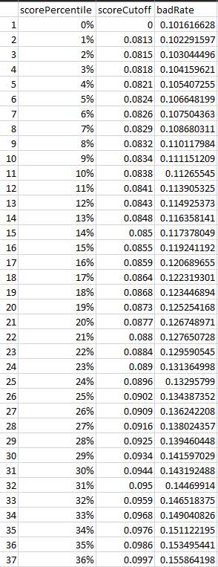

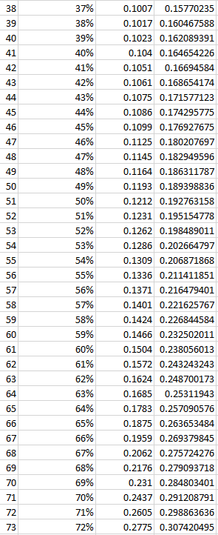

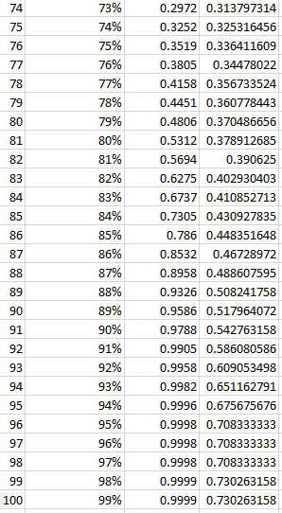
If the score cutoff of the 91 percentile is 0.9905, and the bad rate of 0.5861 is read. This means that if 0.9905 is used as a threshold to classify loans as bad, a bad rate of 58.61% is resulted. This bad rate is equal is the number of observed bad loans over the total number of loans with a score greater than the threshold.

We based on the model isBad_Pred KS value of 0.105, the corresponding transform score after applying sigmoid function would be 0.41. This falls on 78% percentile. We will use 78% percentile as the threshold and the bad rate is 0.3567. This bad srate is equal to the number of observed bad loans over the total number of loans with a score greater than the threshold. This means that if 0.418 is used as the threshold to classify loans as bad, we would expect 36% of the loans issued for greater than 0.418 would turn out be defaulted.
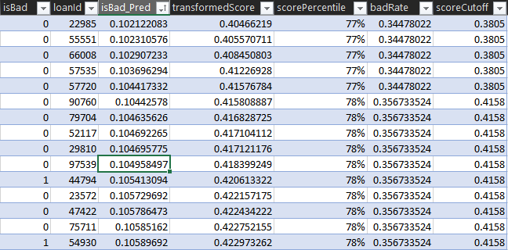

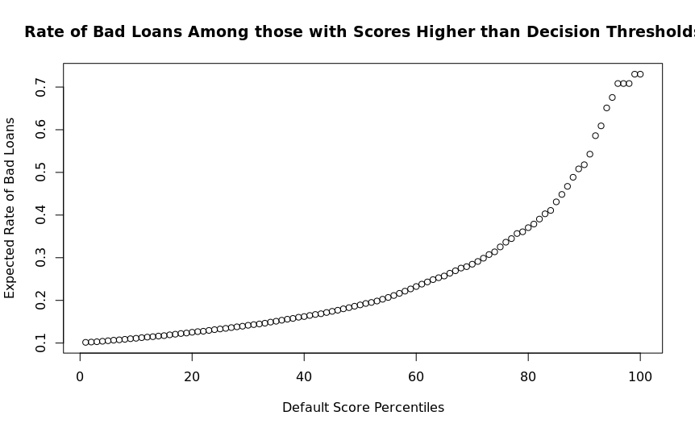

In conclusion Microsoft R server on HDInsight Spark clusters provides distributed and scalable machine learning capabilities for big data, leveraging the combined power of R Server and Apache Spark. The analysis demonstrates how to develop machine learning models for loan credit risk which include data pre-processing, feature engineering, training, and evaluating models, deploys the models as a web service on the edge node and consumes the web service remotely with Microsoft R Server on Azure HDInsight Spark clusters. The HIVE tables are saved containing the predicted scores during both development and production.
In this analysis, we conclude that the score cutoff is at 78% score percentile.

Test Data:
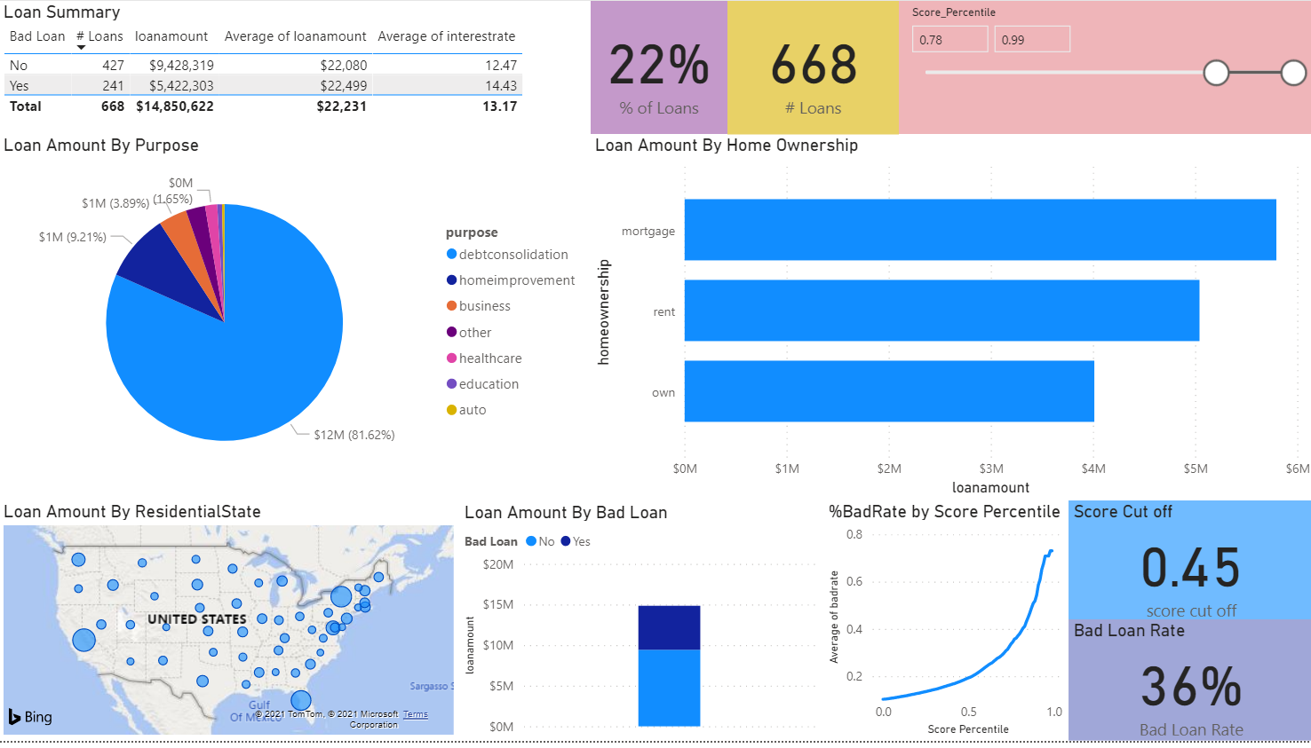
The PowerBI dashboard will allow the visualization and use the predicted scores to decide when to approve a loan. The test data will allow exploration of the scores to decide the cutoff value to use in the decision to reject the loan. The prod data will show new potential loans in the production pipeline where the results can be viewed using the selected cutoff value.
The output scores from the model have been binned according to percentiles, the higher the percentile, the higher the risk of default.
New Loan
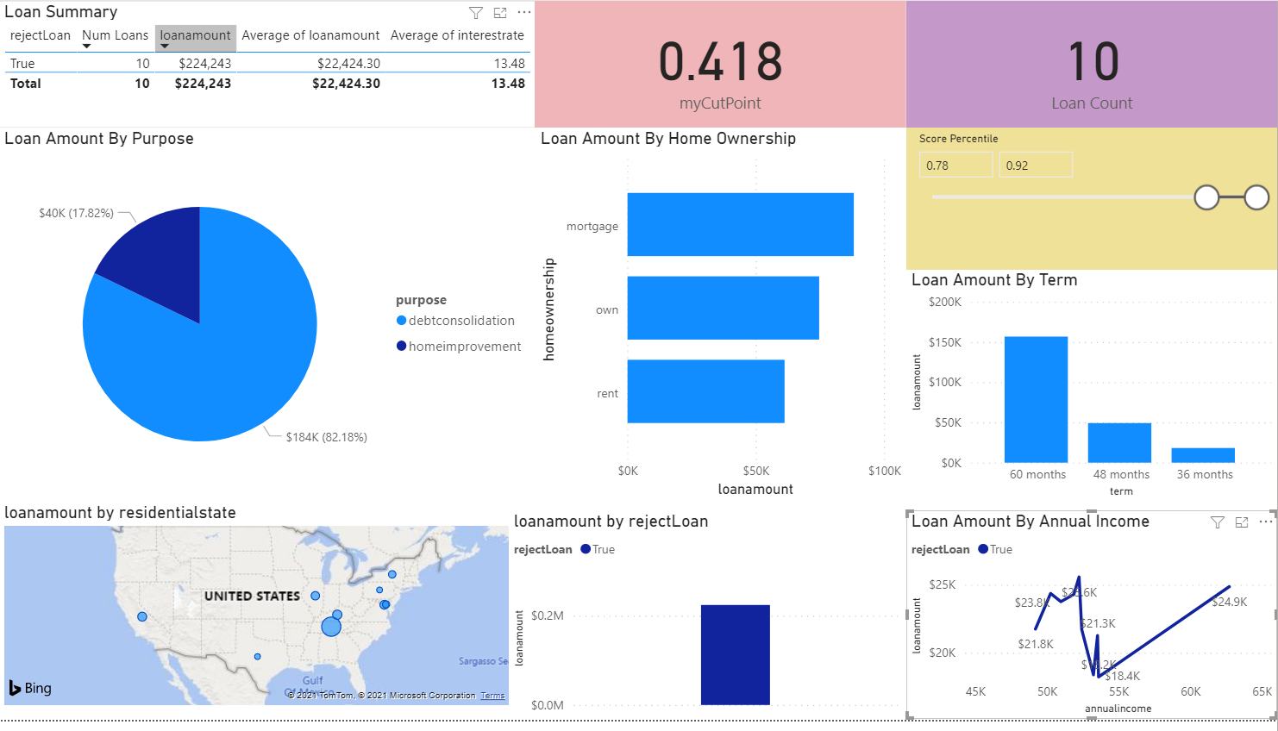

Development_main.R:
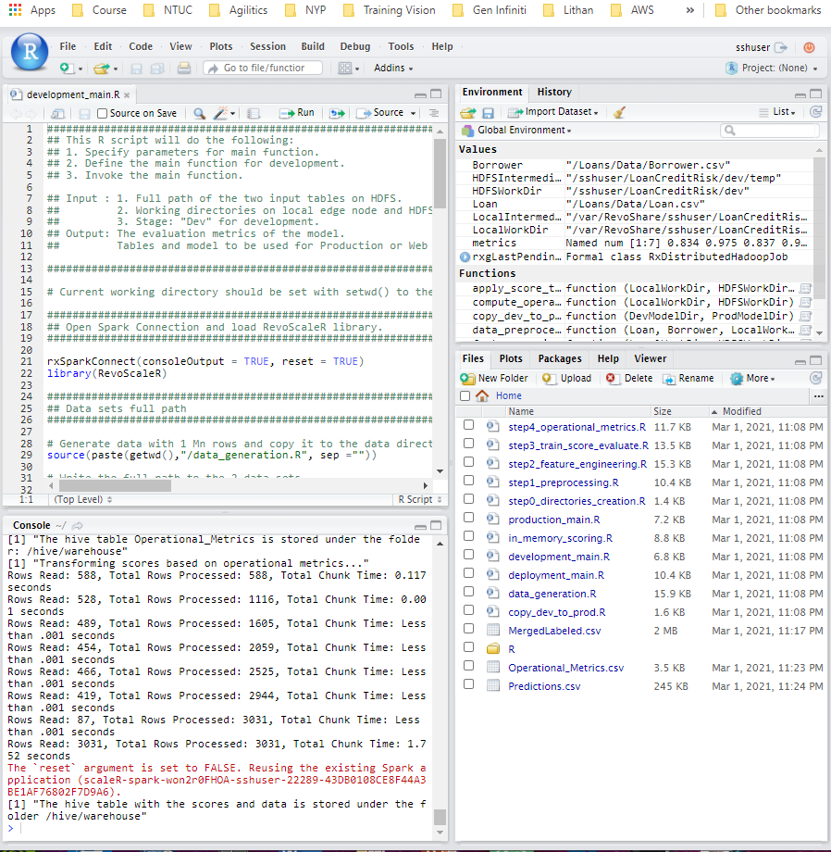

Production_main.R:
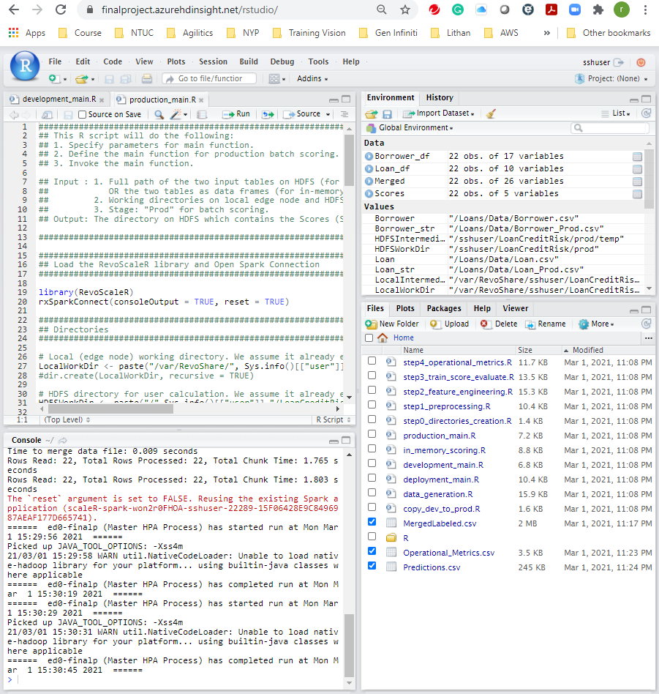

Project Report Sign-off by Mentor & fellow learner

